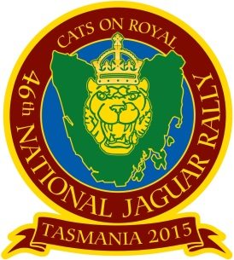
46th Jaguar National Rally
6 - 9 March 2015 - Launceston, Tasmania
Regalia Order Form
Only a small amount of Rally-Specific Regalia will be available at the Rally.
However other Jaguar Regalia will be available for purchase.
Product | Description | Qty +  Size | Price | Total
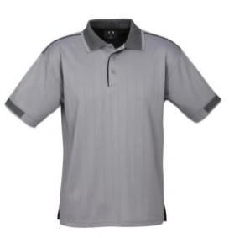 | Mens Polo - Noosa in Silver Grey/Black with embroidered Rally Logo in Black  Biz Cool 100% Breathable - 60% Cotton 40%  Polyester - Contract knitted stripe collar & sleeve.  Loose pocket included - 170 GSM  Available in: S M L XL 2XL 3XL 5XL |  | $35.00
 | Ladies Polo - Blade in Grape/Black or Silver Grey/Black with embroidered Rally Logo in Black  Biz Cool 60% Cotton 40% polyester soft touch jersey - Contrast stitching and piping detail  175 GSM - UPF Rating  Available in: 6 8 10 12 14 16 18 20 22 24 |  | $35.00
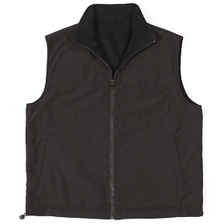 | Reversible Vest Unisex - Black/Black with embroidered Rally Logo in Grey  Polyester/Cotton canvas shell with 100% Polar Fleece lining, low pill.  Pockets on both sides.  Available in: XS S M L XL 2XL 3XL 4XL 5XL |  | $40.00
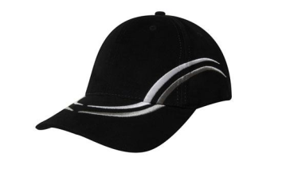 | Baseball Cap with embroidered Rally Logo  Circle on front and "Tasmania 2015" Banner on back of cap.  Black/Grey with logo in Grey. |  | $15.00
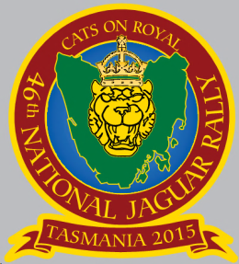 | Metal Badge with Logo  In colour with butterfly clutch on back. |  | $8.00
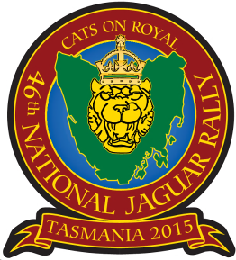 | Embroidered Rally Patches  Iron On, Laser cut Border, in colour. |  | $10.00
TOTAL |  |  |  | $

46th Jaguar National Rally
6 - 9 March 2015 - Launceston, Tasmania
Regalia Order Form
Only a small amount of Rally-Specific Regalia will be available at the Rally.
However other Jaguar Regalia will be available for purchase.

REGALIA PAYMENT OPTIONS

- Option 1: Mail printed order form along with cheque or money order payment
- Option 2: Mail or email order form along with credit card details
- Option 3: Mail or email order form, and make direct bank transfer of funds as below

Cheque / Money Order Payments
Please make all cheques payable to:
JCCT 46th National Jaguar Rally 2015

Credit Card Payments
Card Type (Please tick one) Mastercard Visa
Card Number: | Expiry (mm/yy): / | CVV/CVC No:
Name on Credit Card: | Amount $
Signature

Direct Bank Transfer Payments
Please transfer funds from your nominated account to the following NR15 account.
Please INCLUDE YOUR NAME in the details so we can match the deposit to your purchase.

Bendigo Bank BSB: 633 000 Account No: 152881553
Account Name: JCCT 46th National Jaguar Rally 2015

REGALIA ORDERS

Mail completed orders to: National Jaguar Rally Director
PO Box 131, North Hobart, Tasmania, 7002
or email orders to: NRRegistrations@jagtas.org.au

